Product realization.

____________________________________________________________________________________________________________________________________________________________________________________________________________________________________

Vehicle Accident Prevention System for mountain roads

Kashif Ahmed Farhaana

*a UG , Department of Electrical and Electronics Engineering, Vardhaman College Of Engineering, Shamshabad.*

*_______________________________________________________________________________________________*

**Abstract**

Road traffic injuries are one of the leading causes of death. Road network of India, is about 56 lakh kms.A total of 4,64,910 road accidents have been reported the year 2017 claiming 1,47,000 souls. As many as 1,170 people died in road accidents in the three hill states of Himachal Pradesh, Jammu and Kashmir and Uttarakhand in the first five months of 2019. Moreover, this is not just a localized phenomenon, it’s a global one. There are accidents in Chongqing, China that occur due to the poor engineering of the mountainous roads. A study for this has been published in the paper Estimation of crash severity on Mountainous Freeways in Chongqing. Hence, with the growing traffic and number of roads, it is important to realize the product that is the VAPSMR.

***Keywords- Arduino, Mountain Roads, VAPSMR – Vehicle Accident Prevention System***

## © 2022 – Kashif Ahmed Farhaan.

1. **Introduction**

The motivation for this project stems out of respect for all this lives that have been lost at such roads due to engineering errors. Having known a close friend who had to endure tremendous loss at a very young age due to poor engineering of one such road, I felt the need to implement this project for the sake of solving this engineering problem. Furthermore, a desire to deliver or contribute has had an immense effect on my motivations to create such a system.

## Literature Review

There are many existing solutions for road safety and include many similar systems that use arduino or other systems as in interface to work out the problem. Some of them are:

* **Vehicle speed control and Accident avoidance system:** This system uses an ultrasonic sensor to detect any object that may be in front of the vehicle and accordingly slows the car down. This slowing down of the car is basically breaking. This method also uses regular components available at an electronics store and people with basic knowledge of circuits can make their own. The issue arises in the funding part of the project. After all, there are millions of cars out there which do not have such systems and it’d be logistically impossible to fit all of these cars with such a system at this point.
* **Accident Avoiding System with crash Detection and GPS notification:** This is a very modern approach to the problem of accidents. This system uses an accelerometer to detect sudden speed changes, roll overs that may occur in an accident. This data, when detected, is sent to the GSM module which further transmits the data with the GPS location of the Accident to the authorities who may look into the accident. This system is not for preventing accidents but for responding to the accidents but, at the end of the day, the goal is to save lives.
* **Smart road safety and vehicle accident prevention system**: This product is the most similar to our. It uses the same architecture and components the only thing it lacks is response system for detecting the low visibility, bad weather and horrible road conditions. It uses an Arduino, IR sensors and LED. Unlike the VAPSMR, this system is doesn’t have a moisture sensor or GSM module to send data to the authorities. This system works by detecting traffic on each side of the curve and turning of the respective green or red light on the basis of the connection. The VAPSMR realizes this and optimizes this product to further serve the purpose of saving lives.

## Objective

* The solution is to deliver a system that can alert the drivers on each side of the curve about the other’s presence, which gives the drivers a head up so that they can decide to slow down and be careful.
* This system can solve the issue of overcrowding on the mountain roads and sharp turns as overcrowding is caused by lack of information about the oncoming traffic. This solution essentially solves traffic jams at U turns, S turns, etc.
* Deliver a solution that can work at night time unlike mirrors.
* Be a morally correct alternative to mirrors as they are old tech and depend on a lot of factors that may not be in their favor.
* Deliver a system with high possibilities of expansion at a relatively low price point.
* To notify authorities if there is high chance of accident.

## Methodology

This system consists of 2 parts, first is accident prevention and second is response. The product consists of Arduino UNO which acts like an interface between all components in the design. Furthermore, there are 2 IR sensors which are cross-connected to the LEDs using the arduino uno. The IR sensors, on the field, will be laid of either side of the mountain curve. Whenever an IR sensor will detect vehicles on one side of the curved road, it will turn the red light ON on the other side of the curve. The same will happen to the opposite LED if the opposite IR sensor detects traffic on it’s end. In the case of a dead-lock between the 2 sensors, a buzzer sets an alarm off to let the people on the either side of the curve know of the situation at the moment.

The second part, the response, works if it detects moisture in the soil. This moisture in the soil will signify the existence of thick fog at the curve or rain which makes the visibility go down or makes the road slippery respectively. Both of these conditions are extremely dangerous specially for heavier vehicles due to inertia which may cause the vehicles to fail in rapid deceleration and cause loss of life. This moisture sensor, sends the data to the GSM module such that the authorities responsible for the route may take action to alter the status quo or prevent loss.

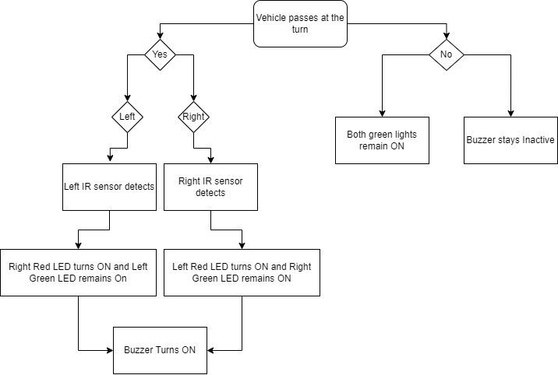

**Fig 3.1 Block Diagram of Accident Prevention Process.**

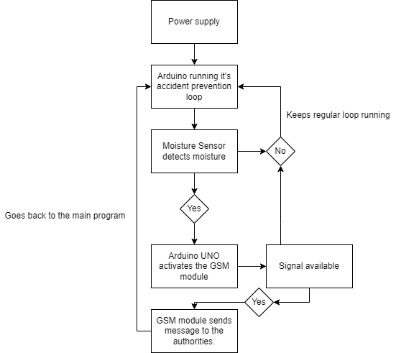

**Fig 3.2 Block Diagram of accident detection**

## Results

The code is dumped into the Arduino UNO with the phone number of the authority involved with taking care of the route.

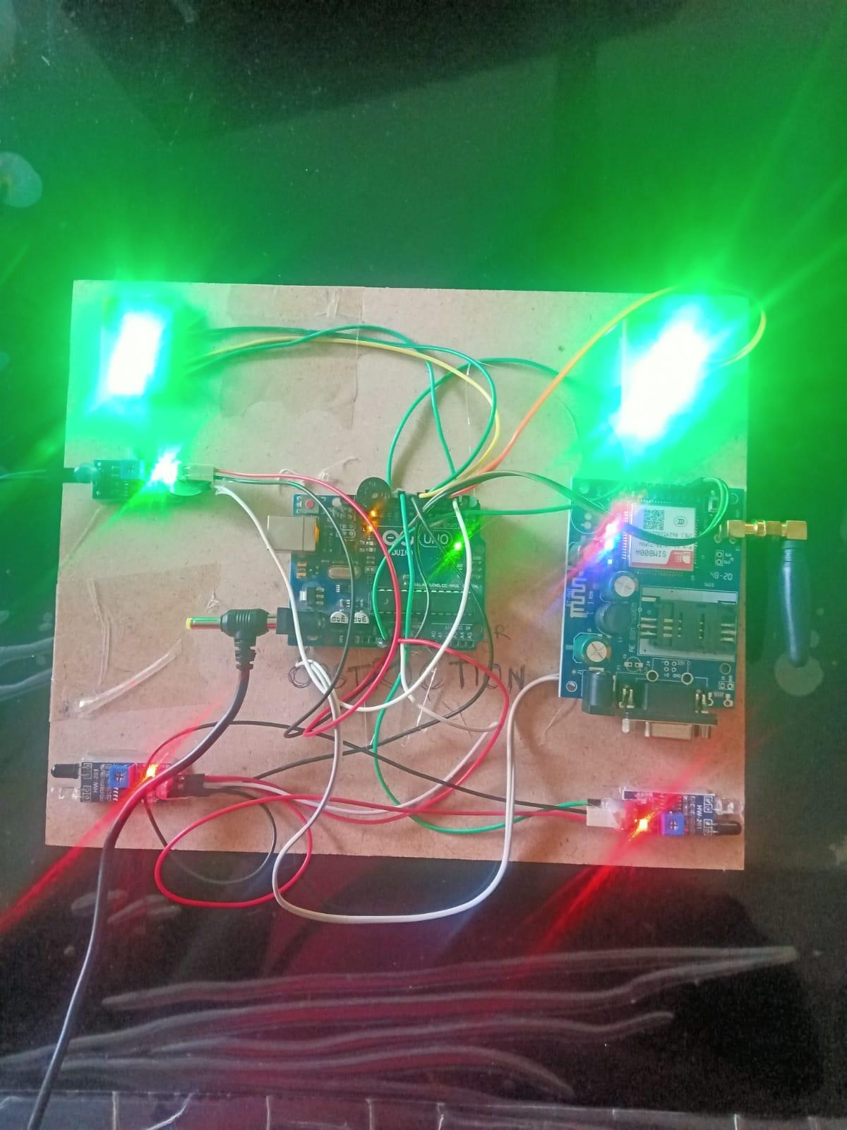

**Fig 4.1 -** No vehicles on either side of the obstruction.

In the figure **Fig 4.1**, there are no vehicle on the either side of the system which here acts as the obstruction between the 2 roads.

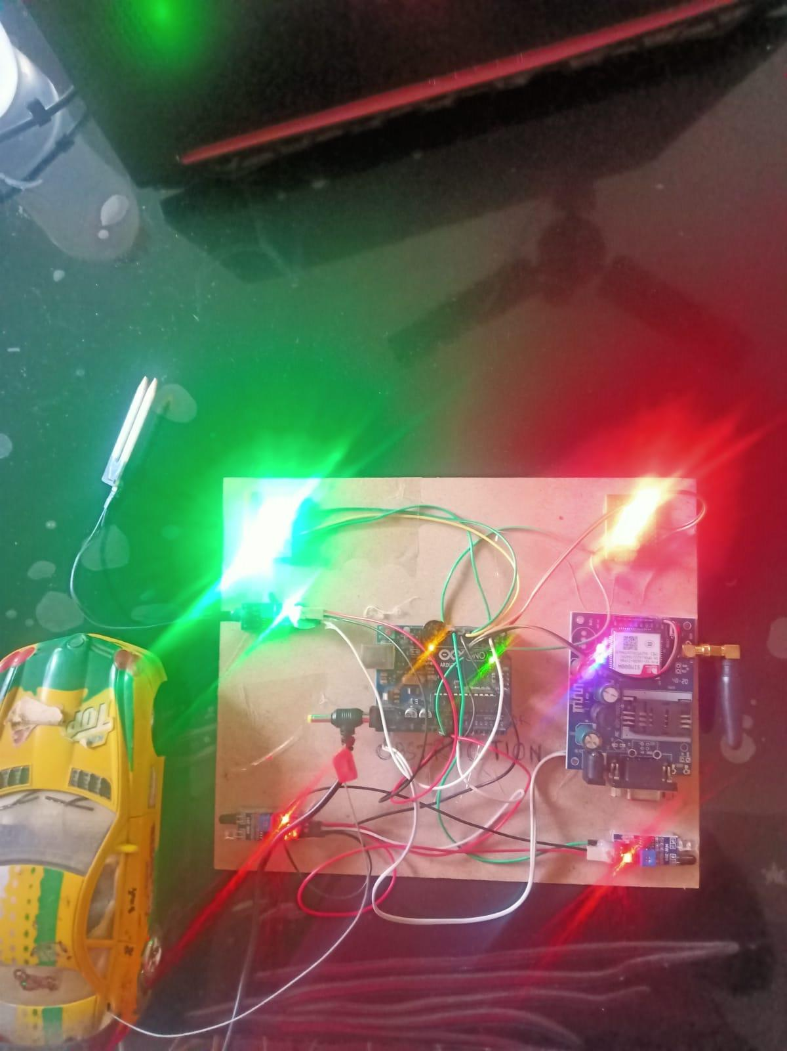

**Fig 4.2 –** Vehicle on the left side of the system.

In the figure **Fig 4.2**, there are is one vehicle on the left side of the system which turns on the Red LED ON on the right side of the system which happens to be on aligned with the road on the right side of the obstruction.

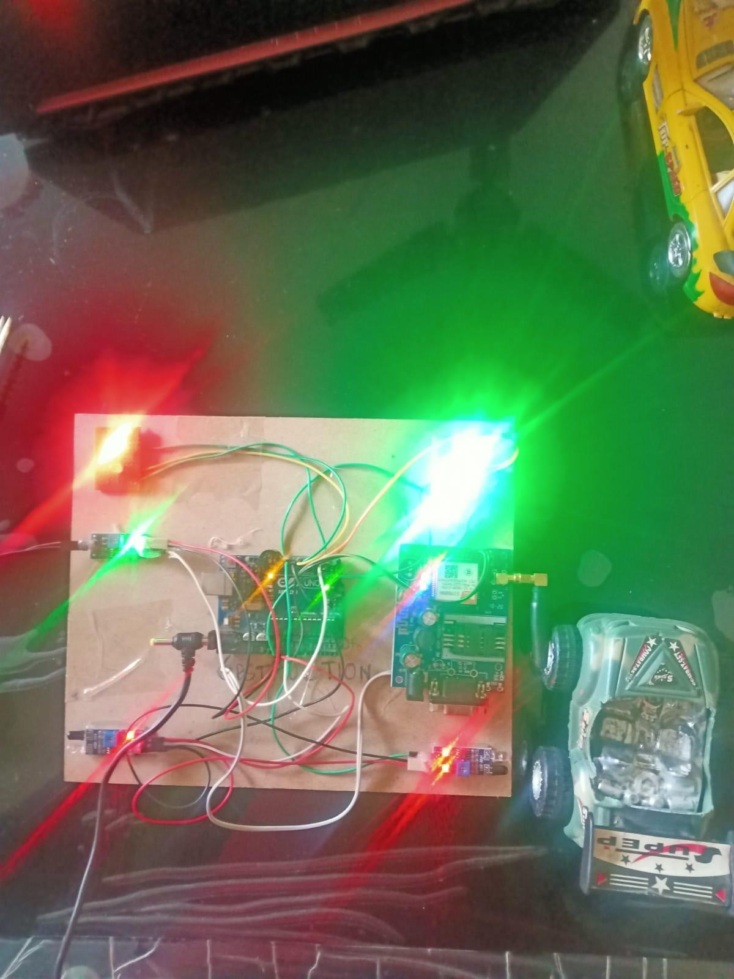

**Fig 4.3 –** Vehicle on the right side of system.

In the figure **Fig 4.3**, there are is one vehicle on the right side of the system which turns on the Red LED ON on the left side of the system which happens to be on aligned with the road on the left side of the obstruction.



**Fig 4.4 –** System sends a warning to the authorities about the conditions of the road.

If the system detects any moisture in the system, it sends the text message in **Fig 4.4** to the authorities about the weather. This can be immensely helpful as it can tell the likeliness of accident beforehand.

## Conclusion

About 2300 years ago, when Alexander the Great campaigned from Macedonia, to Asia minor, to Egypt and finally down to regions which are considered modern day Punjab. He became the man who conquered the known world of the time. Out of his Empire rose the Roman Empire. The greatest military force to ever exist, before the world got guns. The Romans, to keep their own territories in control, to enhance trade, and to continue on with their debauchery, built over 86,000 KMs of roads. They were built for ease of transport on foot or horse-back. But now, we use cars, bikes and other vehicle which go much faster than anything ever seen before in human history. This means, accidents caused by these inventions are far worse than anything ever seen in human history. In order to avoid these tragedies, we need ever-growing, impeccable and robust systems that don’t fail. Our project offers one such system. Our proposition is one of the more pragmatic, and certainly, a more modern approach to a problem that needs solving.

## References

1. Wegman, “The future of road safety: A worldwide perspective,” IATSS Research, vol. 40, no. 2, pp. 66– 71,2017. View at Publisher · View at Google Scholar·
2. European road assessment program (Euro RAP), “European Road Safety Atlas.
3. Delineating road accident risk along mountain roads June 2007 Disaster management.
4. Programming with Arduino, Hans-Petter Halvorsen
5. Estimation of crash severity on Mountainous Freeways in Chongqing by Yunwei Meng.
6. International journal of innovative research in electrical, electronic and instrumentation and control engineering,Vol. 4, Issue 6, June 2016 “Sensor Based Accident Prevention System” by Aravinda, Chaithralakshmi, Deeksha,Ashutha.
7. World Health Organization, “Global status report on road safety2015,”
8. World Health Organization, “Save LIVES - A road safety technical package,”2017.
9. W. E. Marshall, “Understanding international road safety disparities: Why is Australia so much safer thanthe United States?” accident analysis & prevention, 2018.

# Vehicle Accident Prevention System for mountain roads.

7

## Mr.Kashif Ahmed Farhaan

He is an Electronics undergraduate, currently pursuing Bachelors of Tech. At Vardhaman College of Engineering. He has completed his schooling from BSRKV, sainikpuri, Secunderabad – 500010. He is an avid reader, and is interested in making things. Furthermore, he enjoys history.